# Operational Concept Description (OCD)

**<e-Lockbox>**

**<Team 10>**

**<Team members and roles>**

|  |  |
| --- | --- |
| **Cheng Zhang** | **Prototyper / Chief Developer** |
| **Guancheng Li** | **Project Manager/ Prototyper/ Developer** |
| **Yutong Guo** | **Operational Concept Engineer/ Developer/ Tester** |
| **Qing Wei** | **Life Cycle Planner/ Feasibility Analyst/ Developer** |
| **Si Zhao** | **Software Architect/ Tester** |

**<04/11/17>**

# Version History

| Date | Author | Version | Changes made | Rationale |
| --- | --- | --- | --- | --- |
| 10/10/14 | Yutong Guo | 1.0 | * Original template for use with e-Lockbox v1.0 | * Initial draft for use with e-Lockbox v1.0 |
| 10/10/16 | Yutong Guo | 1.1 | * Revise program model and benefit chain diagram * Fix some issues in element relation diagram | * Final version for use with e-Lockbox v1.1 |
| 11/29/16 | Yutong Guo | 2.0 | * Revise system boundary and environment diagram * Revise capability goals and level of service goals * Revise element relationship diagram | * DCR Package with v2.0 |
| 02/12/17 | Yutong Guo | 3.0 | * Revise some diagrams | * RDC Package with v3.0 |
| 04/11/17 | Yutong Guo | 4.0 | * Revise element relationship diagram * Revise some diagrams in business workflow | * As-Built Package with v4.0 |

# Table of Contents

Operational Concept Description (OCD) i

Version History ii

Table of Contents iii

Table of Tables iv

Table of Figures v

1. Introduction 1

1.1 Purpose of the OCD 1

1.2 Status of the OCD 1

2. Shared Vision 2

2.1 Benefits Chain 3

2.2 System Capability Description 3

2.3 System Boundary and Environment 4

3. System Transformation 5

3.1 Information on Current System 5

3.2 System Objectives, Constraints and Priorities 8

3.3 Proposed New Operational Concept 11

3.4 Organizational and Operational Implication 14

# Table of Tables

Table 1: The Program Model 2

Table 2: Artifacts 5

Table 3: Capability Goals 8

Table 4: Level of Service Goals 9

Table 5: Relation to Current System 10

# Table of Figures

Figure 1: Benefits Chain Diagram of e-Lockbox System 3

Figure 2: System Boundary and Environment Diagram of e-Lockbox System 4

Figure 3: Current Business Workflow for Account Creation 6

Figure 4: Current Business Workflow for Case Registration 7

Figure 5: Current Business Workflow for Document Upload 7

Figure 6: Current Business Workflow for Document Download 8

Figure 7: Element Relationship Diagram of e-Lockbox System 11

Figure 8: Business Workflow for Login with Verification Code 12

Figure 9: Business Workflow for Reset Password 13

Figure 10: Business Workflow for Take Survey 14

### Introduction

#### Purpose of the OCD

This document provides, in detail, the shared visions and goals of the stakeholders of e-Lockbox system for Living Advantage. The success-critical stakeholders of the project are Pamela R. Clay, as the project owner; Janice Elizabeth Kreh, as one of the case managers working for Living Advantage; the youth users, as users; CSCI577B Team 10, as the developer.

#### Status of the OCD

The status of the OCD is currently at the version number 4.0 in the Transition Readiness Review

phase. All the OCD main sections have been completed according to the As-Built Package requirements.

### Shared Vision

Our vision, in this project, is to realize a website that makes youth keep and download vital life documents conveniently and securely.

Table : The Program Model

|  |  |  |  |
| --- | --- | --- | --- |
| **Assumptions**   * People will use this system with satisfaction in security and efficiency. * People will trust their case managers and this system in security of protecting their personal information. | | | |
| **Stakeholders** | **Initiatives** | **Value Propositions** | **Beneficiaries** |
| * Living Advantage staff * Youth user * Developer * Maintainer | * Develop login verification code * Maintain the system * Manage cases * Train staff and youth users to use this system * Take surveys | * Improve system security * Improve information management process * Better keep track of youth users * Enable identification of youth users | * Living Advantage staff * Youth user |

#### Benefits Chain

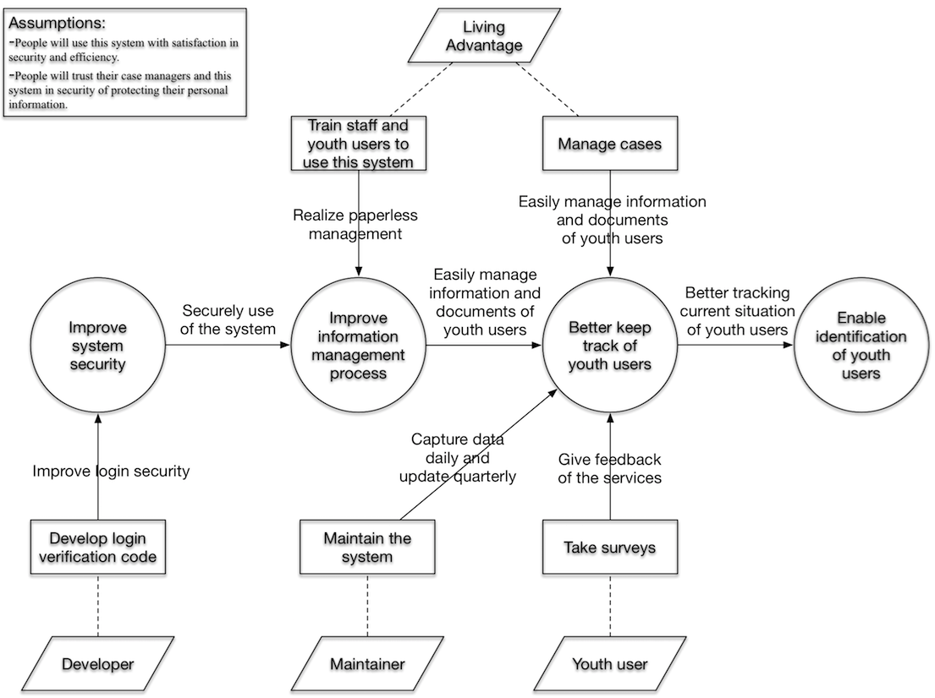

Figure : Benefits Chain Diagram of e-Lockbox System

#### System Capability Description

* The type of system to be built

Put simply, the e-Lockbox is a web-based document management system. All its users will obtain service from the website.

The admins and case managers in Living Advantage will login the system to manage cases and youth’s documents, and generate administrative.

* The target customer(s) for the system

The main purpose of our system e-Lockbox is to help employees working at Living Advantage manage documents securely and conveniently.

The target customer for the system is Living Advantage.

* A compelling reason for the customer to buy/use the system

Now the staff working for Living Advantage do most of their work through Salesforce.com, however Salesforce does not provide report-generating service with the current package. Thus they have to do this manually, which takes a lot of time and effort. And all the case managers share the same account, so it is hard to restrict each case manager’s domain.

Currently the youth have to go to the Living Advantage office to request for copies of their documents. This is an inconvenience and waste of time for both staff and youth.

By using e-Lockbox, Living Advantage and youth will youth will benefit by having secure and convenient access to their records.

#### System Boundary and Environment

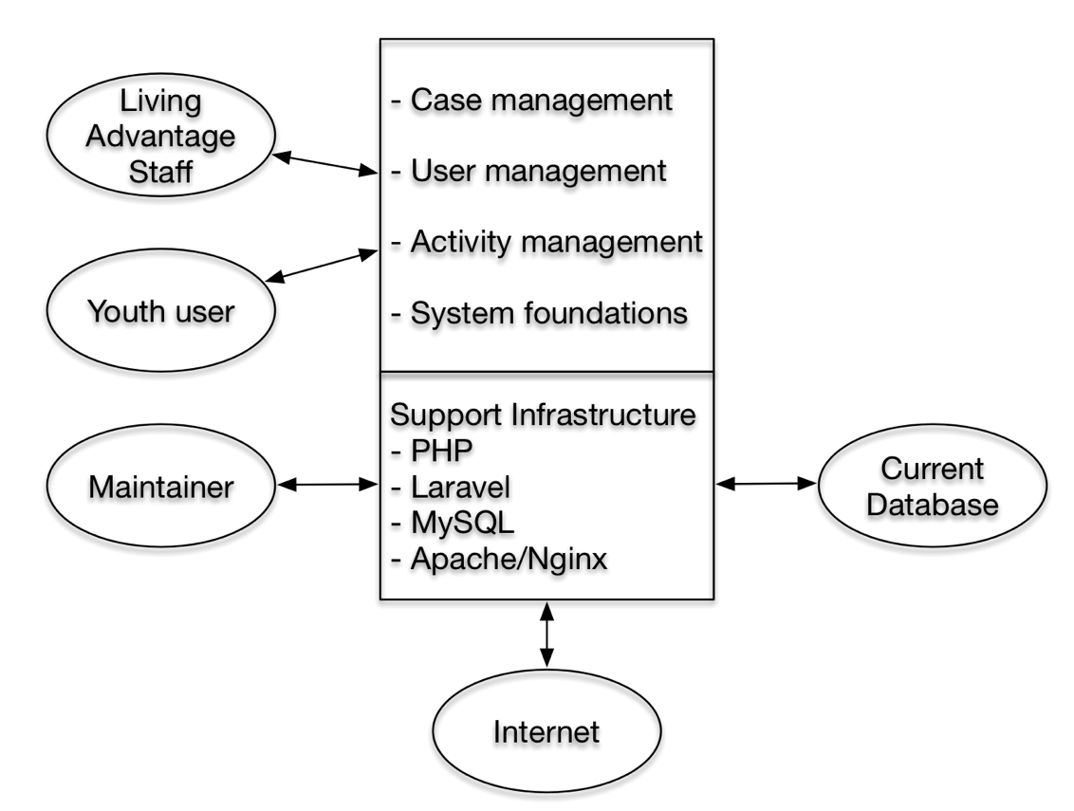

Figure : System Boundary and Environment Diagram of e-Lockbox System

### System Transformation

#### Information on Current System

##### Infrastructure

Current e-Lockbox is a secure system which gathers and stores the vital life documents for youth. And the organization provides limited case management, empower youth to advocate for themselves and assist them to obtain and manage their vital life documents such as birth certificate, social security cards and state photo identification. Youth users can view and download their vital life documents which administrator or case managers uploaded.

* Front-end: Web application.
* PHP Web Framework: Laravel.
* Database: MySQL.
* Programming Language: PHP, JavaScript, HTML, CSS.
* Hardware: Digital Ocean Server.
* Platform: All platform.

##### Artifacts

Table : Artifacts

|  |  |  |  |
| --- | --- | --- | --- |
| **Artifact** | **Description** | **Requested/ Shown/ Received** | **Planned Delivery Date** |
| e-Lockbox INFO LINK  <http://www.livingadvantageinc.org/eLockbox.cfm> | Introduction of the meaning of e-Lockbox and why they want to design this system. | Received | N/A |
| e-Lockbox ACTUAL LINK: <https://www.mylaspace.com/login> | Current realized website of e-Lockbox. | Received | N/A |
| Business Workflow Presentation | Present the current workflow of three kinds of users including administrator, case manager and general user when using the e-Lockbox system. | Shown | N/A |
| Bitbucket Account | Source code and database structure of current system stored on the Bitbucket. | Received | N/A |
| Digital Ocean Account | Current server which the code hosted on. | Received | N/A |

##### Current Business Workflow

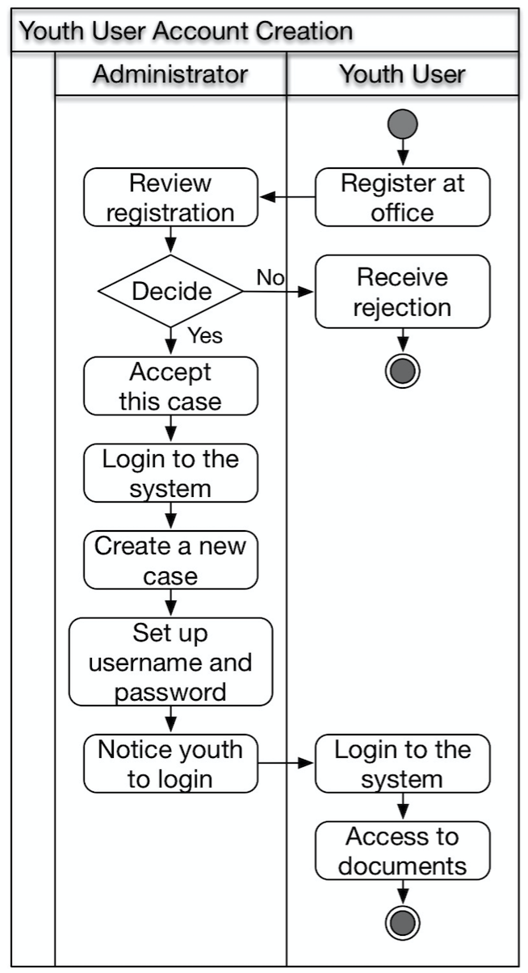

Figure : Current Business Workflow for Account Creation

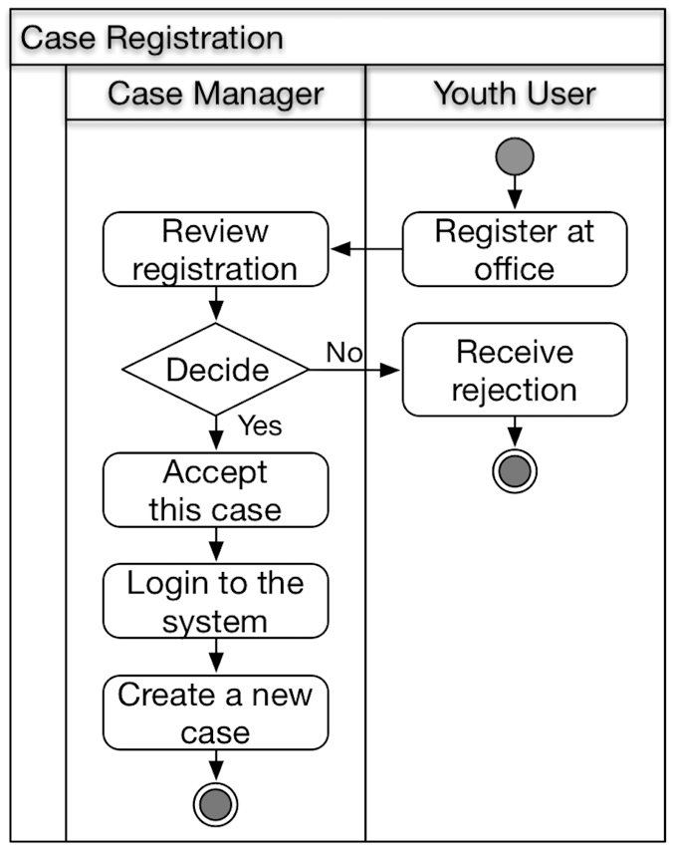

Figure : Current Business Workflow for Case Registration

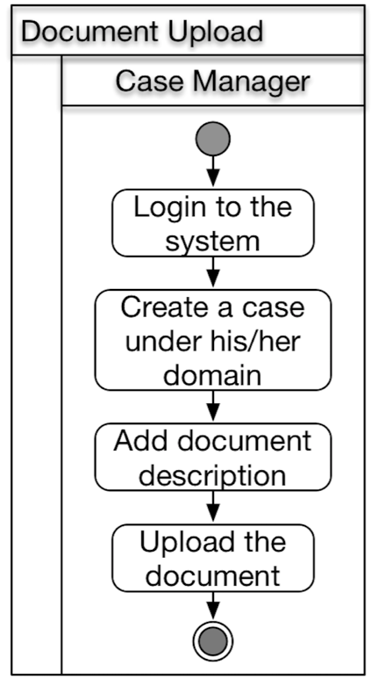

Figure : Current Business Workflow for Document Upload

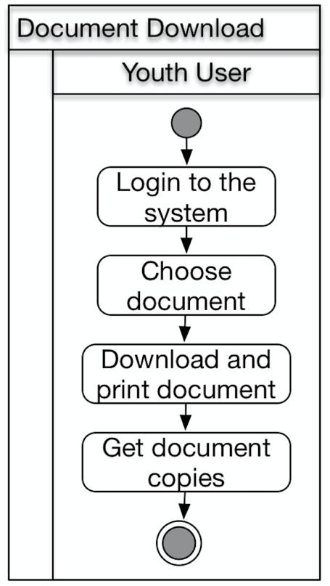

Figure : Current Business Workflow for Document Download

#### System Objectives, Constraints and Priorities

##### Capability Goals

Table : Capability Goals

|  |  |
| --- | --- |
| **Capability Goals** | **Priority Level** |
| **OC-1 Case Management**: Administrators can manage all cases, including operations of new, view, edit and delete. Case managers can manage cases in their scope, including operations of new, view and edit. Staff can view all cases, but cannot edit anything. Case management includes manage case, manage document. | Must Have |
| **OC-2 User Management**: Administrators will be able to manage all kinds of users. Case managers can manage youth users in their scope. Staff can view all users, but cannot edit anything. | Must have |
| **OC-3 Activity Management**: Administrators will be able to manage all activities. Case managers will be able to manage activities related to her/him or her/his case. | Must have |
| **OC-4 System Foundations**: Include authentication, settings, auto logout, set survey link. | Must have |

##### Level of Service Goals

Table : Level of Service Goals

|  |  |  |
| --- | --- | --- |
| **Level of Service Goals** | **Priority Level** | **Referred WinWin Agreements** |
| **LOS-1 Security:** All the documents must be stored securely.  The security specification should include login-control (Verification Code), system-access-control, documents-storage and so on. | Must have | Win-Condition 3935  Win-Condition 3978  Win-Condition 3996  Win-Condition 4005 |
| **LOS-2 Upgrade & Migration:** All the existing functions should be migrated from Laravel 4.1 to Laravel 5.3. | Must have | Win-Condition 40012 |
| **LOS-3 Performance:** UI should be concise and smart. Management process should be efficient. | Must have | Win-Condition 4013  Win-Condition 4014 |
| **LOS-4 Usability:** The system shall be easy to use for youth users and case managers. The usability can be tested by questionnaire and actual operation. | Should have | Win-Condition 4015 |
| **LOS-5 Data Size:** This system should support large data.  Currently, the Living Advantage has 353 kids, each kid has at most 7 documents stored on e-Lockbox system, and each document is about 1MB, thus the total storage is around 2.5GB.  Since Living Advantage predicts to have more foster youth in the future, they prefer to limit the storage capability for each case to be no more 15 documents. Suppose each document can be no more than 3MB, and there are 1000 kids, the total expected storage for documents will be no more than 44GB. | Should have | Win-Condition 4016 |

##### Organizational Goals

**OG-1:** Improve the system security

**OG-2:** Improve information management process

**OG-3:** Better keep track of youth users

**OG-4:** Enable identification of youth users

##### Constraints

Since we have to do development work based on previous system, which was developed in 2013 and 2014. Thus we have constraints in the following area.

**CO-1: PHP as a Development Language:** PHP should be used as a development language.

**CO-2: Laravel as PHP Web Framework:** Laravel should be used as a php web framework.

**CO-3: MySQL as DBMS:** MySQL should be used as a database management system.

**CO-4: DigitalOcean as Server:** DigitalOcean should be used as sever.

##### Relation to Current System

Table : Relation to Current System

|  |  |  |
| --- | --- | --- |
| **Capabilities** | **Current System** | **New System** |
| Roles and Responsibilities | Maintained by Salesforce.com | Have ITs of Living Advantage maintain system including database. |
| User Interactions | Thy system cannot generate demographic information of youth users. | Case managers can generate demographic information according to their different needs. |
| Infrastructure | Under the service of Salesforce.com | Living Advantage will have their own software system. |
| Stakeholder Essentials and Amenities | Current system is a complex and paid, thus difficult to satisfy their specific needs. | Owning their system, they can have specific feature as they want with less money. |
| Future Capabilities | This system only satisfies part of requirements of Living Advantage. | The system will be customized by Living Advantage. |

#### Proposed New Operational Concept

##### Element Relationship Diagram

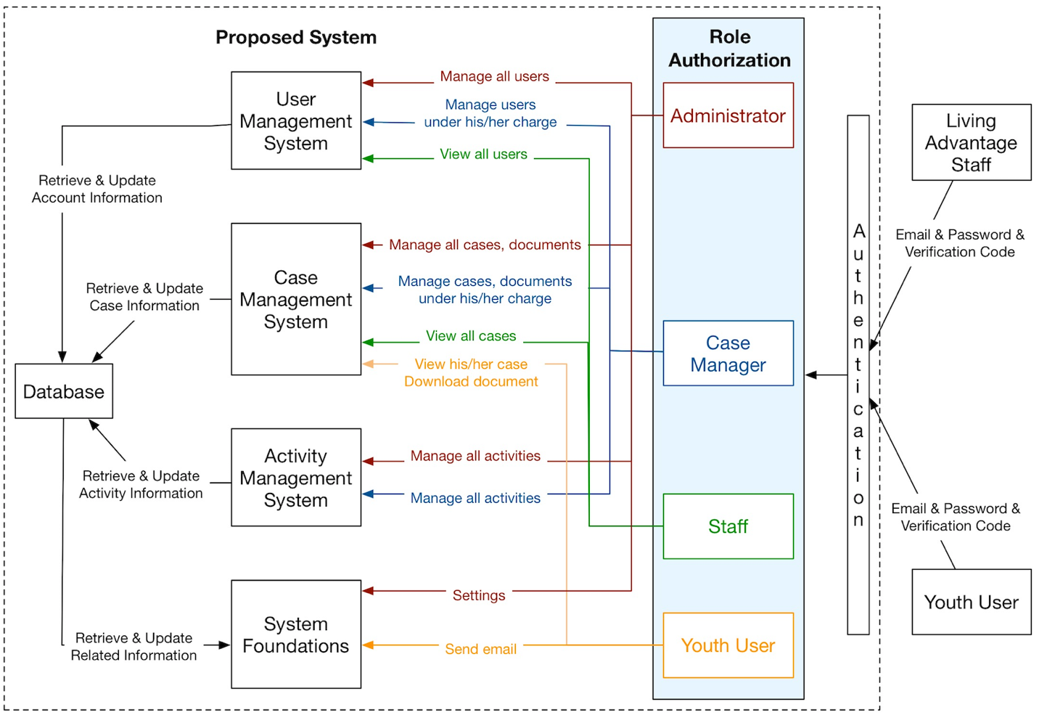

Figure : Element Relationship Diagram of e-Lockbox System

##### Business Workflows

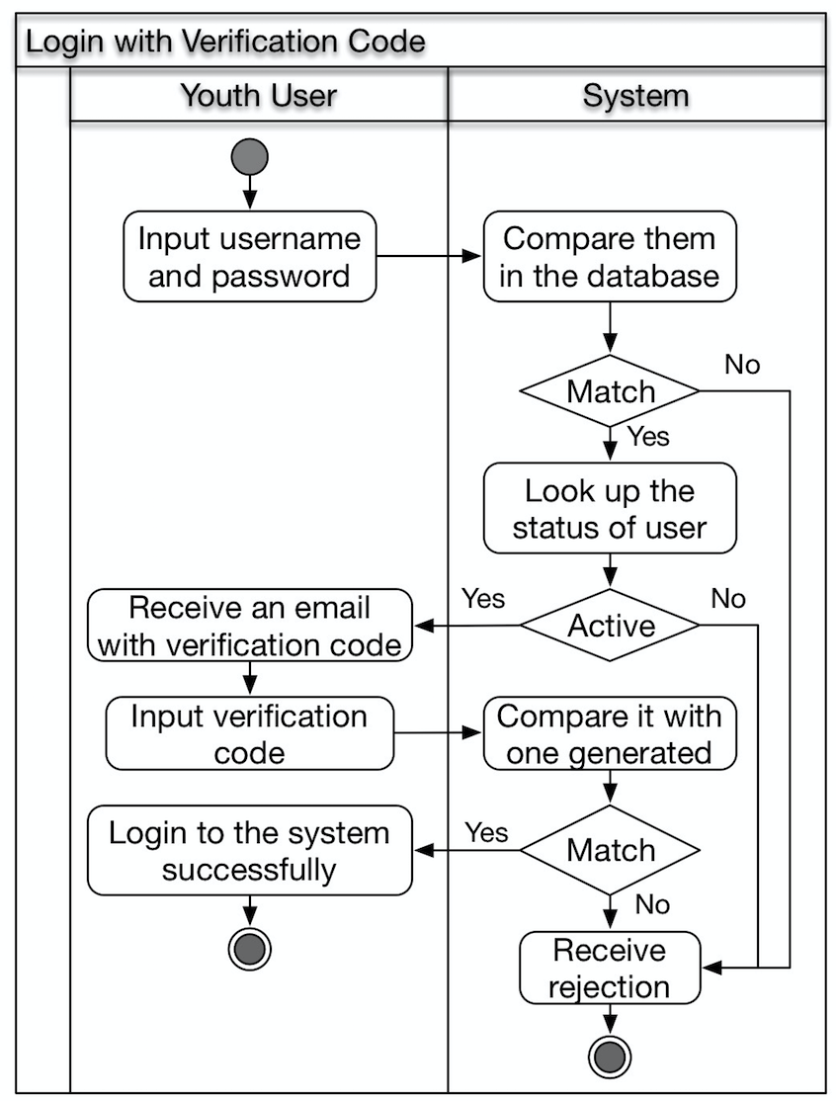

Figure 8: Business Workflow for Login with Verification Code

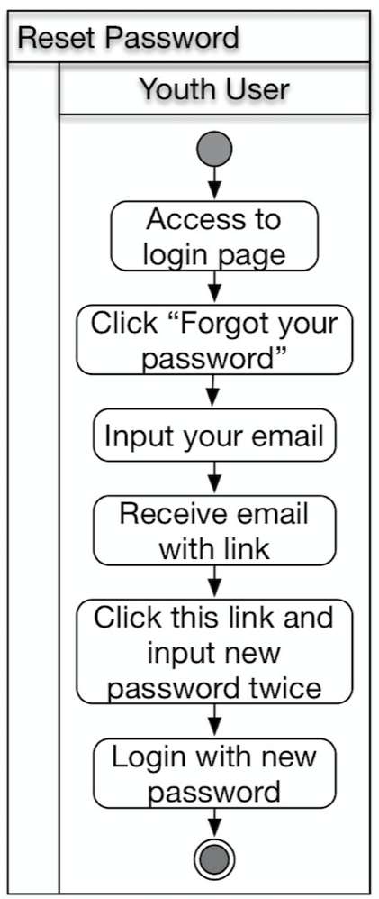

Figure : Business Workflow for Reset Password

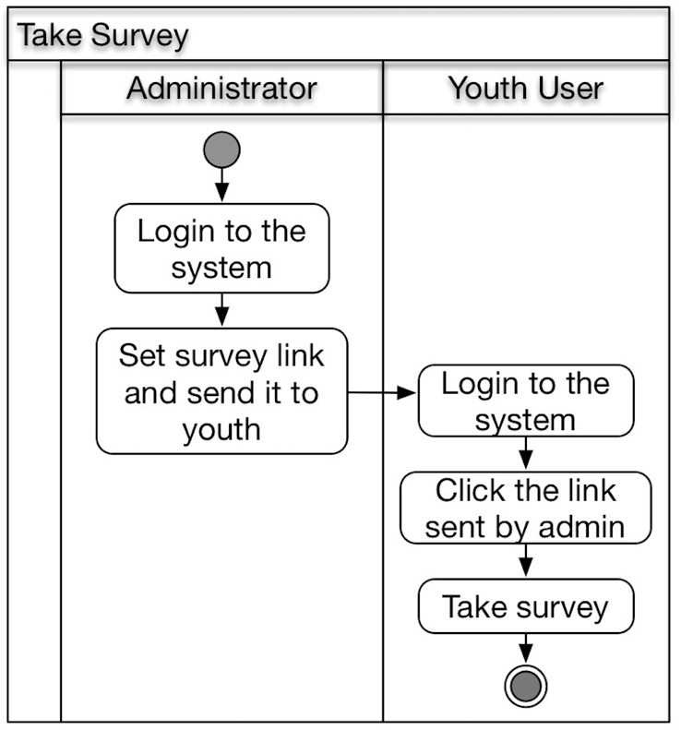

Figure : Business Workflow for Take Survey

#### Organizational and Operational Implication

##### Organizational Transformations

* Living Advantage needs to assign maintainers to take care of the system.
* Living Advantage can be relieved from current, hard-use, time-consuming and limited e-Lockbox system.

##### Operational Transformations

* Youth users can login this system more securely by inputting a verification code sent through email rather than just use the email and password to login.
* Youth users can take the survey in this system.
* Youth can send e-mail to her/his case manager through the new system.
* Admins, case managers and staff can use activity as email to communicate with each other through the new system.
* Staff which is a new user type can view all the information of youth users.